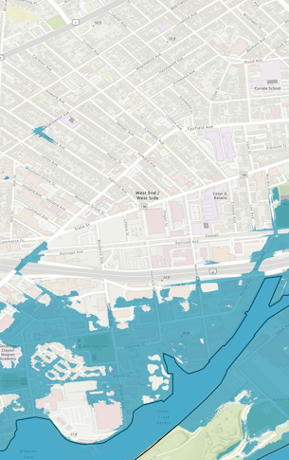

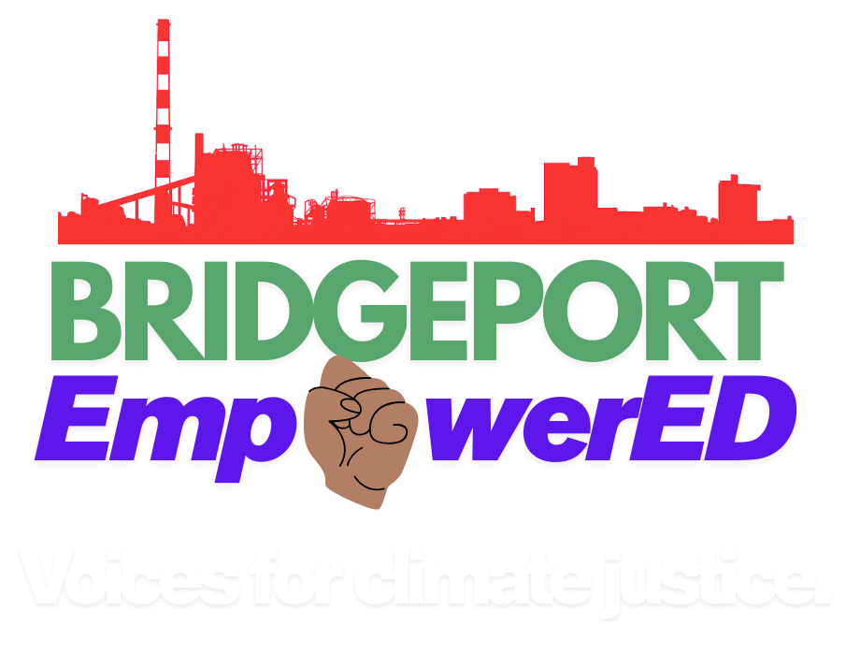
EmpowerED-Carbon Neutral Cities Alliance-Deliverable 3
Curriculum and lesson plans 7/31/2026

Deliverable 3-CNCA-EmpowerED

Table of Contents
Deliverable 3-CNCA-EmpowerED 1
Session Content: 2
Part I Introduction 2
1. October 30 2024_Introduction Part I 2
2. November 20 2024 Introduction Part II 2
3. December 18 2024-Game Night and Holiday Celebration 3
Part II Climate 101 3
4. January 29 2025-Climate Scenarios 3
5. February 26 2025-Introduction to Environmental Justice and Climate Impacts 3
6. March 26, 2025- Where Have We Been and CT DEEP 4
7. April 30 2025-Review 4
8. May 28, 2025, Squad Cafes 4
9. June 25, 2025, Squad cafes 5
10. July 19 2025 Retreat 5
11. August 27 2025- Air, Land, Water, and People 5
12. September 24 2025- Core Systems Part I 6
13. October 29 2025-Core Systems Part II 6
14. November 5 2025-Burning Questions 6
15. November 8 2025 Retreat 7
16. December 3 2025 Squad Videos Discussion 7
Part III Hands-On Solutions Building 8
17. January 28, 2026 Energy pathways 8
18. February 25, 2026 Utilities, electricity, oil, and international politics 8
19. March 25, 2026 Climate Micro labs 8
20. April 29, 2026 Healthy Homes (Mold) 9
21. May 27, 2026 Story Map workshop 9
22. June, 24, 2026 Learning & Solutions Fair 9
23. TBD-Implementing Community Solutions to Climate Change 10

Session Content:
Series | Session
- Introduction | 1, 2, 3
- Climate 101 | 4, 5, 6, 7, 8, 9, 10, 11, 12, 13, 14, 15, 16
- Hands On Solutions Building | 17, 18, 19, 20, 21, 22, 23, 24

Part I Introduction

1. October 30, 2024_Introduction Part I
Introduction Part I of Series
Description of session: An introduction to the project and the partners involved in the project. The facilitator made connections with community members through open discussion and prompting around things they see in their neighborhood and around the City of Bridgeport. They introduced some data around environmental racism, health, asthma, Covid-19, and homelessness to create connections with residents lived experiences.
This session includes:
- Presentation: Yes
- Curriculum/lesson plan: Yes
- Hands on activity: No

2. November 20, 2024, Introduction Part II
Introduction Part I of Series
- Description of session: Discussion and explanation of how existing health related challenges are induced or completely related to environmental pollution, in the absence of climate change. Discussed how these impacts were going to be further exacerbated and made worse by climate change. Solutions to climate change were also discussed
This session includes:
- Presentation: Yes
- Curriculum/lesson plan: Yes
- Hands on activity: No

3. December 18, 2024-Game Night and Holiday Celebration
Introduction Part I of Series
Description of session: Test your knowledge “Flyswatter” game and sustainable holiday gift wrapping. This session was meant to refresh topics previously discussed over the last two sessions and find a way to celebrate the holiday season in a sustainable way. Repurposed items were purchased and wrapped in repurposed textiles
This session includes:
- Presentation: No
- Curriculum/lesson plan: Yes
- Hands on activity: Yes

Part II Climate 101

4. January 29, 2025-Climate Scenarios
Climate 101 Part II of Series
Description of session: Science of greenhouse gas effect. Introduced climate related scenarios and did brainstorming around ways to address it. Introduced new terms and definitions relevant to the course
This session includes:
- Presentation: Yes
- Curriculum/lesson plan: Yes
- Hands on activity: No

5. February 26, 2025-Introduction to Environmental Justice and Climate Impacts
Climate 101 Part II of Series
Description of session: Celebrated Black History Month, We looked toward the future at potential solutions and ideas for rebuilding a sustainable society. Introduced to the concept of climate justice and environmental justice. Discussed what is causing climate change and some of the non-human impacts of climate change (biodiversity loss) and why that matters for humans
This session includes:
- Presentation: Yes
- Curriculum/lesson plan: Yes
- Hands on activity: No

6. March 26, 2025- Where Have We Been and CT DEEP
Climate 101 Part II of Series
Description of session: Review of where we have been, and a discussion around the hiring of a new community climate educator. This session also served as preparation for the CT DEEP Environmental Justice feedback session, providing background and support.
This session includes:
- Presentation: No
- Curriculum/lesson plan: Yes
- Hands on activity: No

7. April 30, 2025-Review
Climate 101 Part II of Series
Description of session: Review of past content and evaluation results. This session will help refine curriculum and content that should be reviewed again or refined. Feedback from the residents should also inform approach to facilitation going forward.
This session includes:
- Presentation: Yes
- Curriculum/lesson plan: Yes
- Hands on activity: No

8. May 28, 2025, Squad Cafes
Climate 101 Part II of Series
Description of session: Squad cafes. Residents assembled into squads to discuss issues pertaining to air quality, health, and climate change impacts they see in Connecticut. The climate change squad café is meant to promote discussion, shared experiences, and issues pertaining to the larger community.
This session includes:
- Presentation: No
- Curriculum/lesson plan: Yes
- Hands on activity: Yes

9. June 25, 2025, Squad cafes
Climate 101 Part II of Series
Description of session: Residents utilized the squad café model to discuss identifying core systems, vulnerabilities to climate impacts, and climate and non-climate stressors that can create vulnerabilities. This session deepened understanding around what influences these climate impacts and outcomes in the hyper local context of their neighborhood. This session also introduced a framework for how climate impacts manifest across different systems.
This session includes:
- Presentation: No
- Curriculum/lesson plan: Yes
- Hands on activity: Yes

10. July 19, 2025, Retreat
Climate 101 Part II of Series
Description of session: This half-day session brought together previously reviewed content and utilized the squad cafes to deepen residents’ understanding around climate impacts, vulnerability, and core systems. This session had a specific focus on introducing concepts of equity, diversity, and inclusion, while also addressing systemic, institutional, and historical problems and barriers. This helped to form a foundation and framework to understand how climate impacts and their severity manifest in communities are impacted by a variety of factors, individuals, and systems
This session includes:
- Presentation: Yes
- Curriculum/lesson plan: Yes
- Hands on activity: Yes

11. August 27, 2025- Air, Land, Water, and People
Climate 101 Part II of Series
Description of session: Introduced 4 buckets of water, air, land and people to better connect residents around important themes. We discussed current issues facing the planet and people, including Flint, the 6th mass extinction and biodiversity loss, AI and water usage, lead pipes, and discolored water. This was meant to help bring up topics that may be relevant for our hands on activity “Put Your Money Where Your Mouth Is”. Residents were given a dollar in change and ask to put coins on the topics land, air, water, and people as they related to their importance. This helped residents connect values and priorities around climate impacts.
This session includes:
- Presentation: Yes
- Curriculum/lesson plan: Yes
- Hands on activity: Yes

12. September 24, 2025- Core Systems Part I
Climate 101 Part II of Series
Description of session: Introduction to research and looking in-depth at local climate impacts in Bridgeport using trusted online sources
This session includes:
- Presentation: No
- Curriculum/lesson plan: Yes
- Hands on activity: Yes

13. October 29, 2025-Core Systems Part II
Climate 101 Part II of Series
Description of session: Continuation of research session on local climate impacts
This session includes:
- Presentation: Yes
- Curriculum/lesson plan: Yes
- Hands on activity: Yes

14. November 5, 2025-Burning Questions
Climate 101 Part II of Series
Description of session: Brainstorming burning questions in groups. Topics were reviewed individually and residents were asked for quick, rapid-fire questions that come to mind. Participants were encouraged to ask big questions, anything was worthwhile. This promoted creative thinking and helped bring forward in-depth topics of interest that could help bring new content to light or bridge connections with previously discussed content
This session includes:
- Presentation: No
- Curriculum/lesson plan: Yes
- Hands on activity: Yes

15. November 8, 2025, Retreat
Climate 101 Part II of Series
Description of session: We continued our discussion around building people power, reviewing the concepts introduced at the last retreat and deepening our discussion around how they relate to climate change and climate justice. This session also included an outdoor activity meant to connect residents with topics being discussed in the real world, this included an in-depth discussion about trees and the surrounding environment such as roadways, hardscapes, and impervious surfaces and heat. Residents tested their knowledge of previous content by playing Jeopardy
This session includes:
- Presentation: Yes
- Curriculum/lesson plan: Yes
- Hands on activity: Yes

16. December 3, 2025, Squad Videos Discussion
Description of session: Squad activity. Each squad watched videos about different topics including electricity, climate change, fossil fuels, extreme weather, and renewable energy. They answered prompts about each video, how it relates to Bridgeport and other questions they have. This would help inform content for the hands-on sessions
This session includes:
- Presentation: No
- Curriculum/lesson plan: Yes
- Hands on activity: Yes

Part III Hands-On Solutions Building

17. January 28, 2026, Energy pathways
Hands on Solutions Building Part III of Series
Description of session: Residents built circuits to learn about how electricity is connected and delivered. This session was meant to develop an understanding around utilities and energy production.
This session includes:
- Presentation: No
- Curriculum/lesson plan: Yes
- Hands on activity: Yes

18. February 25, 2026, Utilities, electricity, oil, and international politics
Hands on Solutions Building Part III of Series
Description of session: This session focused on answering questions that came up related to utilities and the electric grid last session and deepening residents’ understanding of the many factors and influences around fossil fuels, and the electric grid. This session also included more hands-on learning with the simple circuits
This session includes:
- Presentation: Yes
- Curriculum/lesson plan: Yes
- Hands on activity: Yes

19. March 25, 2026, Climate Micro labs
Hands on Solutions Building Part III of Series
Description of session: Provide hands on learning around the major impacts of climate change identified as priority community concerns, such as flooding related to sea level rise, extreme heat, and air pollution. Create connections between previously discussed content and systems level thinking.
This session includes:
- Presentation: Yes
- Curriculum/lesson plan: Yes
- Hands on activity: Yes

20. April 29, 2026, Healthy Homes (Mold)
Hands on Solutions Building Part III of Series
Description of session: Residents looked at hyper local issues in their housing connected with ongoing community efforts to understand, document, and address mold. This helps promote a holistic healthy lifestyle for residents and deepens their understanding around the secondary impacts of climate change events like flooding and how non-climate stressors can exacerbate existing issues.
This session includes:
- Presentation: Yes
- Curriculum/lesson plan: Yes
- Hands on activity: Yes

21. May 27, 2026, Story Map workshop
Hands on Solutions Building Part III of Series
Description of session: Residents utilized aerial maps of Bridgeport and the West End to look at hyper local modeled climate impacts and current land use, including sea level rise, heat, and flood vulnerability. Groups looked for trends, examined vulnerability and how that was spatially distributed across neighborhoods and communities, and discussed possible impacts they would experience and solutions needed.
This session includes:
- Presentation: Yes
- Curriculum/lesson plan: Yes
- Hands on activity: Yes

22. June 24, 2026, Learning & Solutions Fair
Hands on Solutions Building Part III of Series
Description of session: Residents create a trifold using previous slideshows and art supplies to display what they have learned throughout the program
This session includes:
- Presentation: Yes
- Curriculum/lesson plan: Yes
- Hands on activity: Yes

23. TBD-Implementing Community Solutions to Climate Change
Implementing Local Climate Solutions
Hands on Solutions Building Part III of Series
Description of session: Residents engage in identifying a local climate impact and implementing a solution to that impact. In this session residents identified extreme heat, flooding, and air quality concerns. Planting trees in the nearby park was identified as a possible solution. Residents are engaged in the identification, location and species selection, planting, and maintenance
This session includes:
- Presentation: No
- Curriculum/lesson plan: Yes
- Hands on activity: Yes

